**Experiment Procedure Documentation**

**Introduction**

This document captures the instructions to process the image.

**Instructions**

1. Primarily to process a image select an image using “select image”.
2. Select an image and “confirm”.

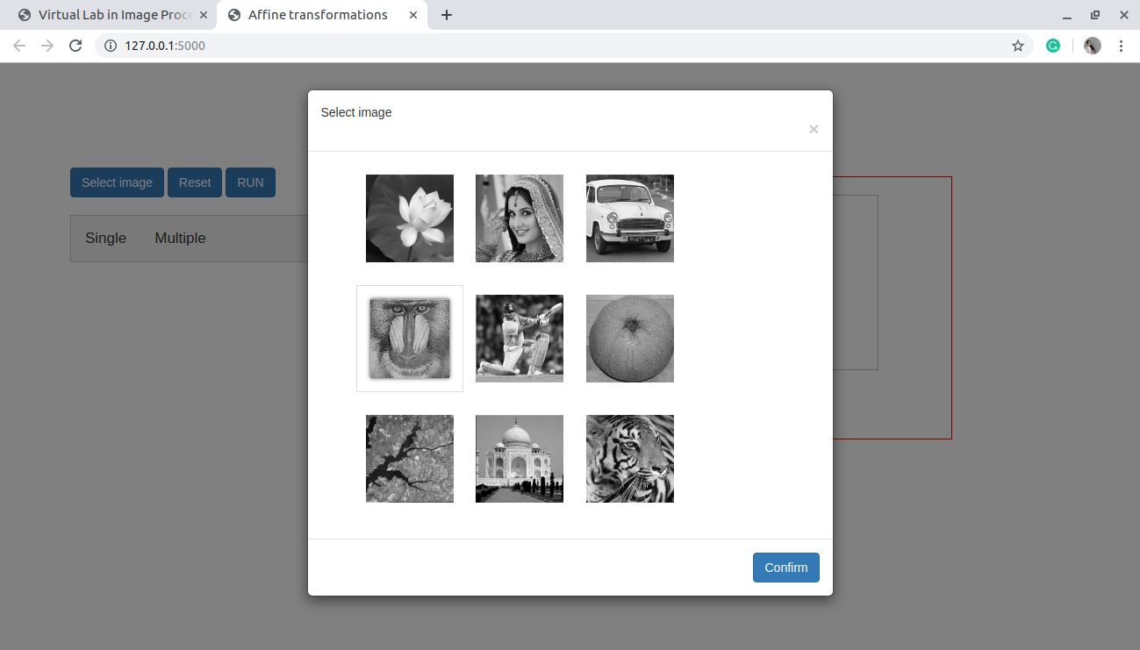

1. Access “single” tab to give input.
2. “interpoation” select one of the “nearest”,”bilinear”,”bicubic”.
3. From radio buttons select any one.

4.1Scaling

upscale – improves the visulization

downscale-deproves the visulization

4.2 Rotation

rotate image with respect to angle

4.3 Translation

translate with respect to x-axis or y-axis

1. “run” to process image and show inside output feild.
2. Obseve the input and output images

